1. Convert the string "258.90" to: (a) integer, (b) floating number. Store in two variables.

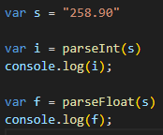

2. Format the number 7.45678 to exactly 2 decimal places (string) then convert it back to a number.

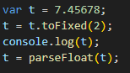

3. Check if the value 'abc' is NaN. Also show a case where isNaN returns false for a non-number.

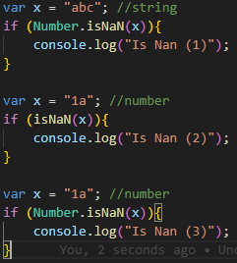

4. Floating point: Show that (0.1 + 0.2) != 0.3. Produce a corrected decimal string with exactly 1 decimal place using toFixed

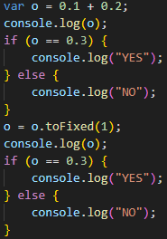

5. Write a function to safely parse a string that may contain trailing text (e.g. "120px") returning the integer part or null if it starts with non-digit.

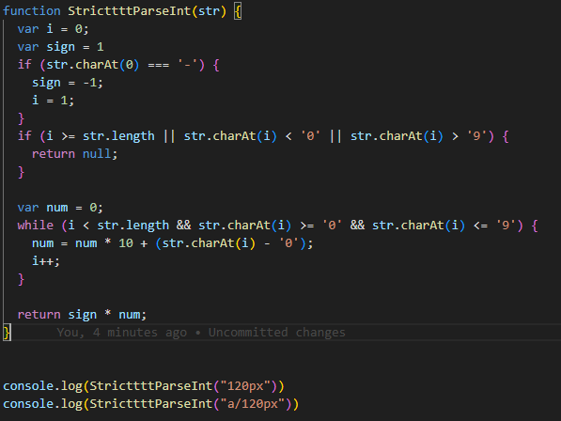 

6. Implement isFiniteNumber(value) that returns true only for finite numeric values (reject numeric strings, Infinity, NaN, null, etc.) WITHOUT using Number.isFinite. Provide 4 passing and 4 failing test examples (comments). 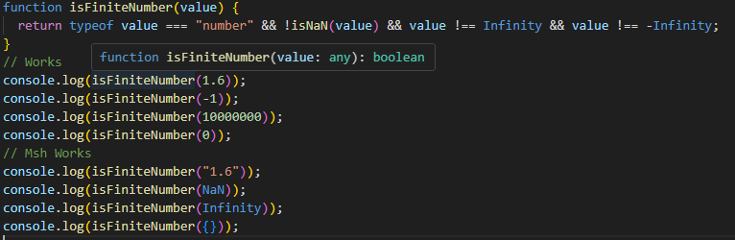 

7. Remove leading and trailing spaces from the string " hello world ".

 

8. Get the substring "script" from "javascript" using two different methods (slice + substring).

 

9. Count how many times the letter 'a' appears in "Banana Mania" (case-insensitive).

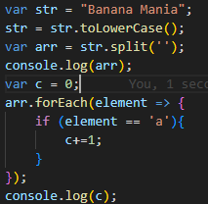 

10. Write a function reverseString(s) without using array reverse (iterate backwards).